**Experiment -1.4**

**Student Name: Parikshit UID:** 19BCS4520

## Branch: CSE-IOT1 Section/Group: 1/A

**Semester:** 4

**Subject Name:** Project Based Learning in Java

**Subject Code:** CSP-296

## Date of Performance:

1. **Aim/Overview of the practical:**

### Create a menu based Java application with the following options: 1.Add an Employee

1. Display All 3.Exit

If option 1 is selected, the application should gather details of the employee like employee name, employee id, designation and salary and store it in a file. If option 2 is selected, the application should display all the employee details. If option 3 is selected the application should exit.

1. **Task to be done:**
   * Create a menu based Java application
   * Option 1 : creating or adding an employee details
   * Option 2 : writing employee details
   * Option 3 : reading employee details
   * Option 4 : displaying employee details
   * Option 5 : exit
2. **Apparatus(For applied/experimental sciences/materials based labs):** nil
3. **Algorithm/Flowchart (For programming based labs):**

### Step 1 :- Create a class named **Employee_6098 ,** having all the required member variables and member functions.

* Step 2 :- Member variables declared here are – empID of type integer , name, designation , salary , contact , all of type String.
* Step 3 :- Call a constructor of the class, passing empID and name as its argument.
* Step 4 :- Make setter and getter methods of all the fields for providing them information and using as per the need.
* Step 5 :- Create a class named **EmpManager_6098 ,** which will define the functionalities required.
* Step 6 :- Functionalities to be defined in the class are – adding an employee , writing details of employee , reading details of employee, and displaying the records.
* Step 7 :- Create a class named **Launcher_6098 ,** which contains the main method to test our logic/program.
* Step 8 :- Create a main menu to ask the user for his choice among adding , writing , reading , or displaying the employee details.
* Step 9 :- Testing our program against all possible test cases.

1. **Theme/Interests definition( For creative domains):** nil
2. **Steps for experiment/practical:** Source Code :-

### Employee Class ::

**import** java.io.Serializable;

**public class** Employee_6098 **implements** Serializable

{

**int** empID_6098;

String name_6098, designation_6098, salary_6098, contact_6098;

Employee_6098(**int** empID_6098, String name_6098)

{

**this**.empID_6098 = empID_6098;

**this**.name_6098 = name_6098;

}

**void** setEmpID_6098(**int** empID_6098)

{

**this**.empID_6098 = empID_6098;

}

**void** setName_6098(String name_6098)

{

**this**.name_6098 = name_6098;

}

**void** setDesignation_6098(String designation_6098)

{

**this**.designation_6098 = designation_6098;

}

**void** setSalary_6098(String salary_6098)

{

**this**.salary_6098 = salary_6098;

}

**void** setContact_6098(String contact_6098)

{

**this**.contact_6098 = contact_6098;

}

**int** getEmpID_6098()

{

**return this**.empID_6098;

}

String getName_6098()

{

**return this**.name_6098;

}

String getDesignation_6098()

{

**return this**.designation_6098;

}

String getSalary_6098()

{

**return this**.salary_6098;

}

String getContact_6098()

{

**return this**.contact_6098;

}

}

### EmpManager Class ::

**import** java.io.File;

**import** java.io.FileInputStream; **import** java.io.FileNotFoundException; **import** java.io.FileOutputStream; **import** java.io.IOException;

**import** java.io.ObjectInputStream; **import** java.io.ObjectOutputStream; **import** java.util.ArrayList; **import** java.util.List;

**import** java.util.Scanner;

**public class** EmpManager_6098

{

List<Employee_6098> l_6098 = **new** ArrayList<>(); List<Employee_6098> readList_6098;

**void** addEmployee_6098(Scanner s_6098)

{



");

");

System.***out***.println(" -->> Enter the employee ID : "); **int** empid_6098 = s_6098.nextInt(); System.***out***.println(" -->> Enter the employee name :

String name_6098 = s_6098.next(); System.***out***.println(" -->> Enter the designation : "); String designation_6098 = s_6098.next(); System.***out***.println(" -->> Enter the salary : "); String sal_6098 = s_6098.next(); System.***out***.println(" -->> Enter the contact number :

String contact_6098 = s_6098.next();

Employee_6098 e_6098 = **new** Employee_6098(empid_6098, name_6098);

e_6098.setDesignation_6098(designation_6098); e_6098.setSalary_6098(sal_6098); e_6098.setContact_6098(contact_6098); l_6098.add(e_6098);

**for**(Employee_6098 item_6098 : l_6098)

{

System.***out***.println(" >> Employee added successfully " + item_6098.getEmpID_6098() + " " + item_6098.getName_6098());

}

System.***out***.println(" >> Employee added successfully "

+ l_6098);

}

**void** writeData_6098(String name_6098)

{

**if**(name_6098 != **null** && !name_6098.isEmpty())

{

**if**(l_6098.size() > 0)

{

File f_6098 = **new** File(name_6098);

#### try

{

FileOutputStream(f_6098);

FileOutputStream nFOS_6098 = **new**

ObjectOutputStream nOOS_6098 = **new**

ObjectOutputStream(nFOS_6098);

nOOS_6098.writeObject(l_6098);

System.***out***.println(" >> Writing process completed successfully");

}

**catch**(FileNotFoundException e)

{

e.printStackTrace();

}

**catch**(IOException e)

{

e.printStackTrace();

}

}

#### else

{

System.***out***.println(" >> No employee exists.

Create some employee first");

}

}

#### else

{

");

}

}

System.***out***.println(" -->> Provide the file name :

**void** readEmpData_6098(String name_6098)

{

**if**(name_6098 != **null** && !name_6098.isEmpty())

{

File f_6098 = **new** File(name_6098);

**if**(f_6098.exists())

{

#### try

{

FileInputStream(f_6098);

FileInputStream fFIS_6098 = **new**

ObjectInputStream fOIS_6098 = **new**

ObjectInputStream(fFIS_6098);

readList_6098 = (List<Employee_6098>)

fOIS_6098.readObject();

successfully");

}

System.***out***.println(" >> Employee read

**catch**(FileNotFoundException e)

{

e.printStackTrace();

}

**catch**(IOException e)

{

e.printStackTrace();

}

**catch**(ClassNotFoundException e)

{

}

}

#### else

{

e.printStackTrace();

exists");

}

}

System.***out***.println(" >> File does not

}



**void** displayRecords_6098(String name_6098)

{

readEmpData_6098(name_6098);

**if**(readList_6098.size() > 0)

{

System.***out***.println("");



System.***out***.println(" EmpID Name Designation Salary Contact");

**for**(Employee_6098 item_6098 : readList_6098)

{

System.***out***.println(" "+item_6098.getEmpID_6098()+" "+item_6098.getName_6098()+" "+item_6098.getDesignation_6098()+" "+item_6098.getSalary_6098()+" "+item_6098.getContact_6098());

}

exists");

}

}

}

#### else

{

}

System.***out***.println(" >> Employee does not

### Launcher Class ::

**import** java.util.Scanner;

**public class** Launcher_6098

{

Scanner s_6098 = **new** Scanner(System.***in***);

**int** option_6098;

**public static void** main(String args[])

{

Launcher_6098 l_6098 = **new** Launcher_6098(); EmpManager_6098 em_6098 = **new** EmpManager_6098(); l_6098.mainMenu_6098(l_6098, em_6098);

}

**void** mainMenu_6098(Launcher_6098 l_6098, EmpManager_6098 em_6098)

{

System.***out***.println(""); System.***out***.println(" !! Main Menu !! "); System.***out***.println("1. Create Employee");

System.***out***.println("2. Write employee details"); System.***out***.println("3. Read employee details"); System.***out***.println("4. Display employee details"); System.***out***.println("5. Exit the menu");

option_6098 = s_6098.nextInt();

**switch**(option_6098)

{

**case** 1:

System.***out***.println(" !! You are in create

employee area !! ");

em_6098.addEmployee_6098(s_6098); mainMenu_6098(l_6098, em_6098); **break**;

**case** 2:

System.***out***.println(" !! You are in write

employee area !! ");

em_6098.writeData_6098("test.txt"); mainMenu_6098(l_6098, em_6098); **break**;

**case** 3:

System.***out***.println(" !! You are in read

employee area !! ");

em_6098.readEmpData_6098("test.txt"); mainMenu_6098(l_6098, em_6098); **break**;

**case** 4:

System.***out***.println(" !! You are in display

employee area !! ");

em_6098.displayRecords_6098("test.txt"); mainMenu_6098(l_6098, em_6098);

#### break;

**case** 5:

System.***out***.println(" !! Exited !! "); System.*exit*(0);

#### break;

}

}

}

1. **Observations/Discussions(For applied/experimental sciences/materials based labs):** nil

## Percentage error (if any or applicable): nil

1. **Calculations/ Chemical Reactions / Theorems /Formulas used etc :** nil
2. **Result/Output/Writing Summary:** Output ::
   * Initial look –

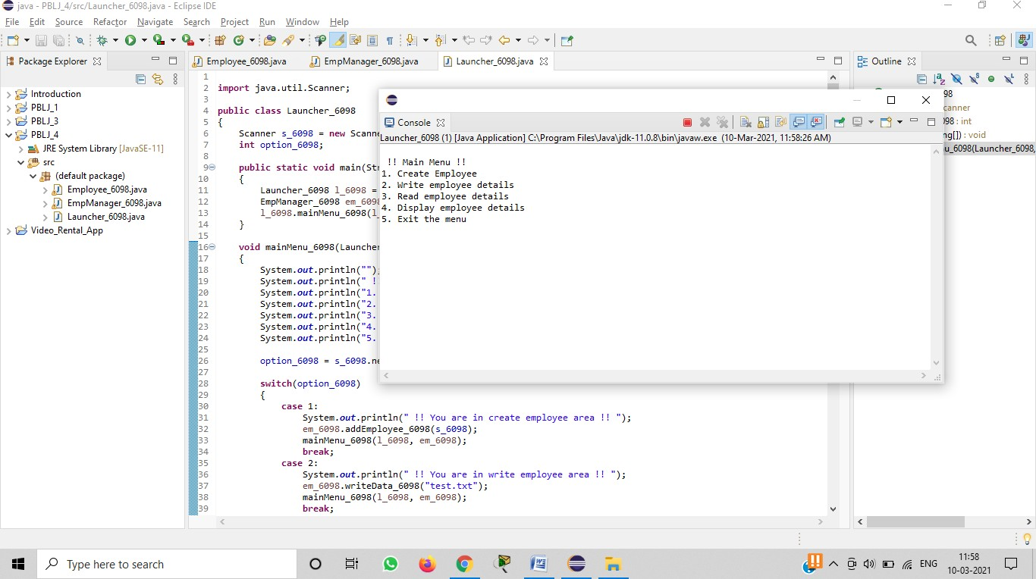

* + Creating an employee –

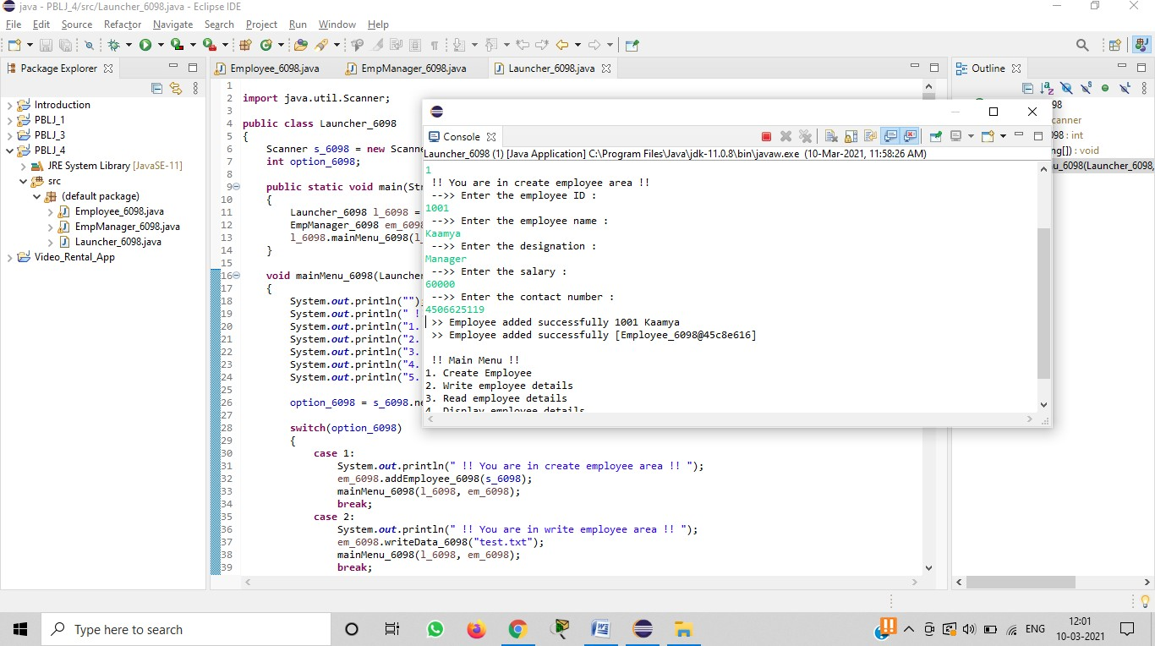



Discover . Lea i 4. E s power.

# GRADE¥ D"

ACCREDITED UNIVERSITY

* + Writing data of employee –

@ K_ s'+^

va Lau nc he r_60g8.java [ ” 6 p”• Ou II i ne ” 6

a s .

  

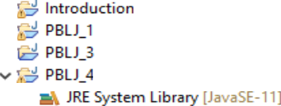" S c ann* Launch er 6098 (1) [Java Applie ation] C:\ Pro9 ram F iies‘\Java\j dk-11.0.8\ bin‘\|avaw.ex e (10-Mar-2021, :'i8:26 AM)

» employee added su<<ess*ully [zmployee_sea s<seuiu]

,g))



cu )

„ „, ,;„pg....) » wiring process completed su<<essf«lly



; ,y(.. ?. Wnitv’vmployuv’dutails





gfi Q Type here to sea rch

* + Reading data of employee –



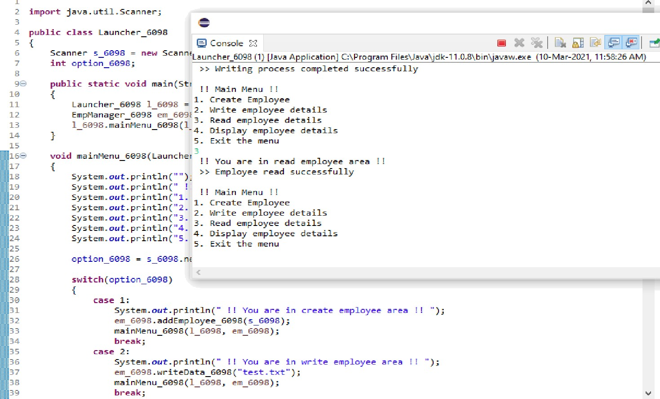

12:03



Discover . Lea i 4. E s power.

# GRADE¥ D"

ACCREDITED UNIVERSITY

* + Displaying employee details –
* 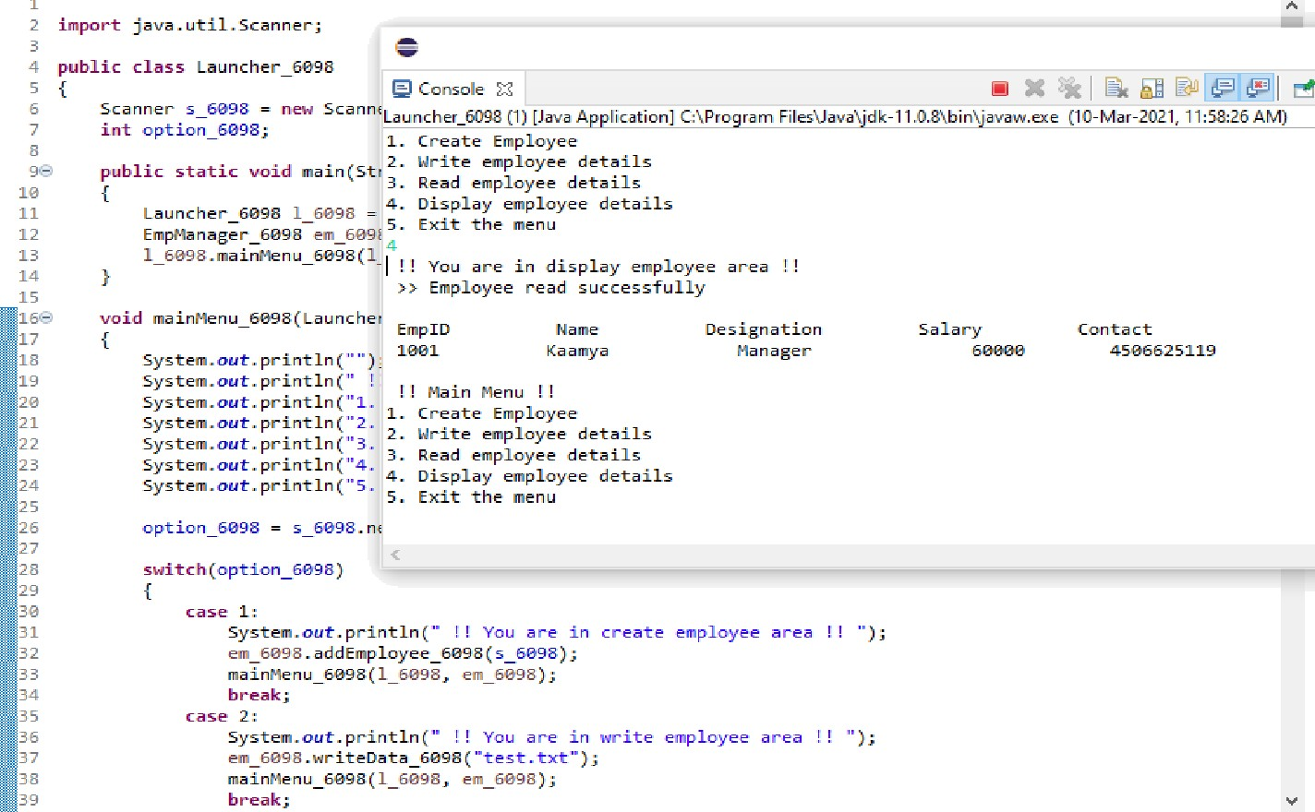cu c e F'efa ct c- NJ a--- ie at e e ai c h Pre e ct Pu a in cic <' Hei



Vid eo_R ental_Ap p

6 • & @ | 9’

ava D ” EN °—- Ou t line D ” 6



cu )

### Exiting –

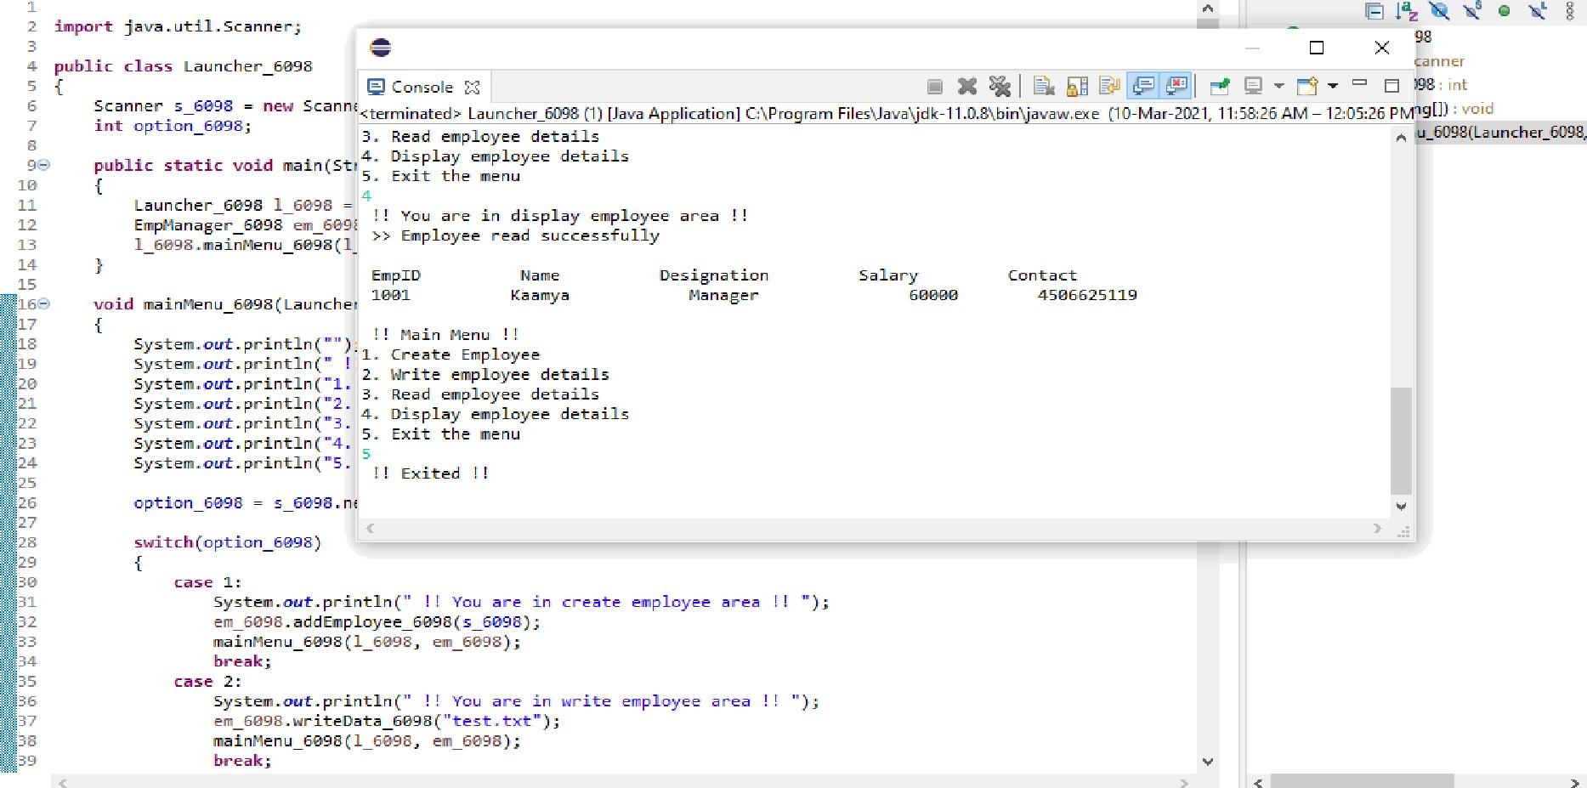

fiB Q here to search



1. **Graphs (If Any): Image /Soft copy of graph paper to be attached here:** nil
2. **Learning outcomes (What I have learnt):**

### Learnt about the concept of files.

1. Learnt about the concept of serializable.
2. Learnt about file handling.
3. Learnt about implementation of file handling.
4. Learnt about the concept of array list and how to work with it.
5. **Evaluation Grid (To be created as per the SOP and Assessment guidelines by the faculty):**

|  |  |  |  |
| --- | --- | --- | --- |
| Sr. No. | Parameters | Marks Obtained | Maximum Marks |
| 1. |  |  |  |
| 2. |  |  |  |
| 3. |  |  |  |
|  |  |  |  |